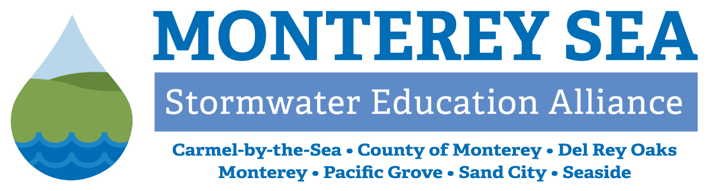
Monterey Regional Stormwater Management Program
Attachment 1
Management Committee
MEETING MINUTES for February 26, 2025

AGENDA ITEMS

- Call to Order / Roll-Call
Chairperson Anderson (City of Monterey) called the meeting to order at 9:30 a.m. and performed the roll call.

Management Committee Members: | Monterey One Water (M1W, Program Administrator):
City of Carmel-by-the-Sea – Val Gaino | Michelle Bumgardner
City of Del Rey Oaks – Ron Fucci | Erica Parker
City of Monterey – Kevin Anderson | Mike McCullough (virtual)
City of Pacific Grove – George Fuerst
City of Sand City – Leon Gomez | Other In-Person:
City of Seaside – Patrick Grogan | Maris Sidenstecker (PE/PO Coordinator)
County of Monterey – Michael Trapani | Mollie Wooden (Pebble Beach Company)

- Public Comments
Chairperson Anderson called for public comment, none received.
- Approve Management Committee Meeting Minutes for 01/22/2025
Action: On a motion by Gomez (City of Sand City), seconded by Fuerst (City of Pacific Grove), Management Committee (MC) unanimously approved the Management Committee Meeting Minutes for 01/22/2025.

Information and Discussion Items
- Update on PE/PO Program
Monthly Update by Sidenstecker
Sidenstecker briefed the Committee on school presentations delivered in January, storm drain emblem stenciling in Pacific Grove, volunteer recruitment efforts from the California State University Monterey Bay - Service Learning Institute, and inspection of Our Water Our World (OWOW) product labels at Home Depot in Seaside. Members discussed the process for producing the bilingual TV ads and storm drain emblem installation with data from jurisdictions’ maps. Trapani (County of Monterey) explained the prioritization of “high traffic” inlets to narrow down the County’s large number of storm drains and focus where the most people will see the emblems. Gomez mentioned that his staff will note locations of missing emblems when they conduct catch basin cleaning around Sand City. Fuerst inquired about community outreach efforts to encourage the public to identify missing emblems; Parker (M1W) stated that the www.MontereySEA.org site has a “Love Your Storm Drains” page where the public can submit addresses of the drains they see without emblems, though it is under-utilized by residents. There is an opportunity for social media campaigns and publicity to raise awareness of that element of the Program.
Upcoming outreach events include City of Monterey Cutting and Horticultural Day, Whalefest Monterey, Earth Days, and Snapshot Day. MRSWMP provides a portion of funding for Snapshot Day through the PE/PO budget. Sidenstecker described the evolution of hotel/visitor outreach on pollution concerns – the Program no longer places brochures or advertisements at hotels in the area, instead placing ads in the Monterey County Weekly (MCW) Visitors Guide. Each hotel receives copies of this Guide from MCW every year, so the return on investment is significantly better than previous approaches.
Cigarette butt collection was discussed, and Gaino (City of Carmel-by-the-Sea) reminded the MC that they have a significant amount of cigarette waste receptacles available to share with other jurisdictions. Fuerst shared that Pacific Grove installed six of the 12 they received and inquired about the efficacy of the TerraCycle recycling process for waste.
Gaino asked about advertising on other platforms like YouTube, with ad buys targeting zip codes. Vice Chair Grogan (City of Seaside) suggested the discussion of further outreach be discussed offline.
  - Follow-up action: Parker will confirm with California Marine Sanctuary Foundation regarding what reporting the MC can expect following the analysis of samples from Snapshot Day.
  - Follow-up action: Parker will send copies of the MCW ads to MC Members for use in their jurisdictions’ publications.
  - Follow-up action: Parker will look into TerraCycle and report back to the MC on her findings.

- Stormwater Training Updates
Drywell Training Webinar Debrief – Gregor Patsch, Travis Pacheco from Oldcastle Infrastructure
Bumgardner (M1W) informed the MC that 52 individual emails signed onto the training session, with some representing multiple participants. This resulted in an approximate attendance of 75 people at the February offering. The recording and presentation slides are posted on the MontereySEA website and available to the public. Members shared positive feedback from their staff and appreciation for the drywell concept that enables the installation of stormwater infrastructure in areas crowded with utilities and other small footprint sites.
- Follow-up action: Support staff will convene a Training Ad Hoc Committee meeting in March.
- Follow-up action: Support staff will disseminate an on-demand training resource to the MRSWMP distribution list and MC Members in April on Post-Construction Requirements.

- Ad Hoc Committee for Memorandum of Agreement Update
Parker provided a brief update on the MOA Ad Hoc Committee meeting on February 18, 2025, and noted that there will be a second Ad Hoc meeting in March.
- Follow up action: Parker will share further information on the process and content development for the MOA.
- Follow-up action: Support staff will look into including specifications requirements for MC Member virtual participation in meetings and ability therein to vote on agenda items.

- Fiscal Year 2025-2026 Budget Discussion
Parker reviewed the FY 25-26 MRSWMP budget preliminary draft, highlighting categories where specific line items were identified to facilitate tracking expenditures. In response to Member questions, she explained the timing for MRSWMP invoicing will be clarified in the MOA updates and acknowledged that FY 24-25 invoices have been delayed; the Program Administrator intends to bill biannually for expenses incurred on a set schedule to be laid out in the MOA.
- Follow-up action: Parker will reach out again to OWOW contact regarding next fiscal year’s subscription cost.
- Follow-up action: Support staff will bring data on historical budget costs for PE/PO contract and contingency amounts, on 2024 MRSWMP discussions of allocating savings from reduced staff levels, and on the evolution of the Fixed Fee Portion of Schedule A.
- Follow-up action: A draft budget proposal for the MC’s consideration will be agendized for the March MC meeting.
  - PE/PO Request for Proposals (RFP) for FY 25-26
Bumgardner expanded on the issuance of an RFP for the PE/PO contract published on February 24, 2025, on the M1W website and sent out to several firms directly. Members inquired about previous contract amounts, and support staff explained the difference in the FY 25-26 budget draft reflects increased costs of conducting business and evolution of successful outreach strategies.
- Follow-up action: Bumgardner will report back on the inclusion of an option to renew contracts awarded through the RFP process.
Member Gaino left the meeting at 10:33 am.
- 2025 Committee Meeting Calendar
Support staff reviewed the meeting calendar and asked Members to share important event dates held by each jurisdiction. Fuerst inquired about meeting dates at the end of 2025 and formalize an adjustment that incorporates holidays.
- Follow-up action: Support staff will agendize an action item to adjust November and December 2025 meeting schedule.

ACTION ITEMS
- Consider Adoption of Committee Member Code of Conduct Policy
Parker introduced the work underway by Program Administrator support staff to develop a Committee Manual for MC Members with resources on requirements, expectations, and other pertinent information for their tenure with MRSWMP. Following best practices for commissions, councils, and other boards, she presented a draft Code of Conduct for approval and subsequent inclusion in the Manual.
Action: On a motion by Fuerst, seconded by Grogan, the MC approved the Code of Conduct with the revisions reflected below.
Ayes: Anderson, Fuerst, Fucci, Grogan, Gomez, Trapani
Noes: None
Absent: Gaino
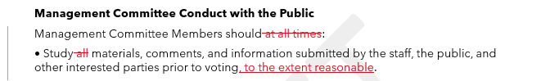

ADMINISTRATIVE REPORTS
- Program Administrator Update
  - Briefing for Chair and Vice Chair, Committee Manual
Parker shared the Briefing for the Chair and Vice Chair. Anderson expressed appreciation for the content to support his newly assumed role as Chair.
- Follow up action: Support staff will share additional Brown Act and parliamentary rules of order resources with Members.
Additional verbal updates from support staff were as follows:
June 2025 is the estimated release date of the MS4 Permit Formal Draft for public comment and review.
The State Water Resources Control Board (SWRCB) unanimously adopted the Cost Reporting Policy on January 22, 2025, to take effect in 2026. Costs incurred by Permittees to comply with stormwater regulations starting July 1, 2026, must be tracked and included in Annual Reports henceforth.
Member Alternates for the Cities of Carmel, Monterey, and the County of Monterey have been provided to support staff. The official process for designating Members and Alternates will be included in the updated MOA, potentially by an annual letter from each jurisdiction.
An Urban Stormwater Infiltration Water Quality Control Policy is under development by the SWRCB; Waterboard staff will be gathering feedback over the next eight months, after which there will be a formal draft review process. Further details are available here: https://www.waterboards.ca.gov/water_issues/programs/stormwater/storms/projects/urban_stormwater_infiltration_policy.html.
- Follow-up action: Parker will monitor progress and inform the MC when further information is available.
- Management Committee Member Updates
  - City of Carmel-by-the-Sea: No report.
  - City of Del Rey Oaks: Fucci reported that the Rosita Rd project is nearing completion, with paving this week and road reopening shortly thereafter. FORTAG construction underway includes concrete grinding on Carlton, and bridge girders have been installed.
  - City of Monterey: Anderson shared that he attended a 2NFORM training session in their MS4 Compliance webinar series on industrial/commercial compliance module. There are inspection reports included in this module that can be used in the field, and he found the training very useful. They hired a consultant to work on the Stormwater Master Plan, in order to establish fees and provide funding for associated work. Fact finding for formalizing the Coastal Land Use Plan is happening now, with numerous examples drawn from the Pacific Grove Plan
  - City of Pacific Grove: No report.
  - City of Sand City: Gomez mentioned that the 2025 Public Works Officers Institute, hosted by the League of California Cities, occurs on March 19, 2025.
  - City of Seaside: No report.
  - County of Monterey: Trapani stated they have made significant headway in mapping drainage ditches and defining the characteristics in the Gabilan watershed for the related TMDL under development.

Schedule Next Meeting / Adjournment
- Schedule Next Meeting
The next MC Meeting is scheduled for Wednesday, March 26, 2025, at 9:30 a.m.
- Meeting Adjournment
The meeting was adjourned at 11:12 a.m.

