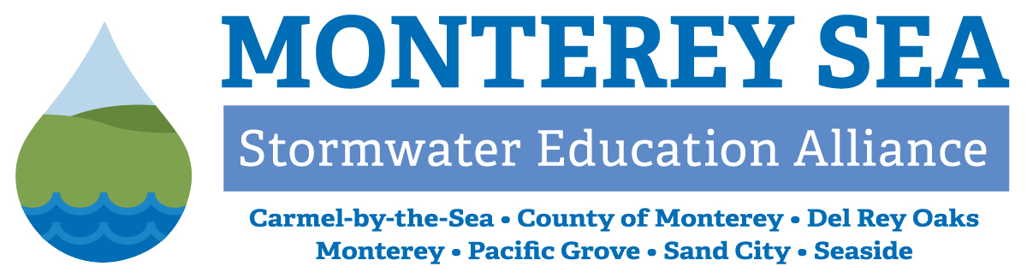
Monterey Regional Stormwater Management Program
Attachment 1
Management Committee
MEETING MINUTES for December 11, 2024

AGENDA ITEMS

- Call to Order / Roll-Call
Chairperson Gomez (City of Sand City) called the meeting to order at 9:30 a.m. and performed roll call.

Management Committee Members: | Monterey One Water (Program Administrator):
City of Carmel-by-the-Sea – Mary Bilse | Michelle Bumgardner
City of Del Rey Oaks – Ron Fucci | Erica Parker
City of Monterey – Kevin Anderson
City of Pacific Grove – George Fuerst | Other In-Person:
City of Sand City – Leon Gomez | Maris Sidenstecker (PE/PO Coordinator)
City of Seaside – Patrick Grogan | Val Gaino (City of Carmel-by-the-Sea)
County of Monterey – Michael Trapani
Other Virtual:
Lindsay Brown (California Marine Sanctuary Foundation –
CMSF, & Monterey Bay National Marine Sanctuary)

- Public Comments
Chairperson Gomez called for public comment, none received.
- Approve Management Committee Meeting Minutes for 9/25/24
- Action: On a motion by Trapani (County of Monterey), seconded by Grogan (City of Seaside), Management Committee (MC) unanimously approved the Management Committee Meeting Minutes for 10/30/2024.

Information and Discussion Items
- Update on PE/PO Program
- Monthly Update by Sidenstecker
Sidenstecker briefed the Committee on school presentations delivered in November and advertisements currently running at the Del Monte Theater in Monterey. She also provided an overview of Storm Water Awareness Week social media engagement rates, comparing 2024 and 2022 statistics, and Doggy Doo competition reach for 2019, 2020, 2021, and 2023.
Members requested a presentation during a future meeting on overall social media statistics for the Committee’s accounts, to better understand the growth over time and the impact of various strategies. Additionally, members directed MRSWMP Program Administrator support staff to develop recommendations on social media processes to maximize reach and engagement.
- Mid-Year Update
Support staff shared a newly developed chart showing progress on Annual Report Measurable Goals; they will maintain this throughout the permit year to provide a snapshot of year-to-date work accomplished.

- Stormwater Training Updates
  - Training Debrief
11/14/24 Construction Best Management Practices (BMP)
Support staff stated that there were 86 total participants, with 49 in person and 37 online. Members shared positive feedback and gratitude for Grogan’s presentation, praising it as one of the best they’ve seen. One comment included a request to include time for Questions and Answers.
  - Drywell Training – February 2025, provided by Gregor Patsch from Torrent Resources
The Committee specified that any training offered should have an online option to facilitate municipal staff participation and that the ideal length of a presentation is 45 minutes. Support staff will work with Patsch to ensure the training focuses on drywell maintenance, the element Members identified as the priority for this topic.

- Use of MontereySEA Branding
The Committee discussed the reasoning behind utilizing MontereySEA as the outward-facing branding – to promote public awareness – and the MRSWMP designation for internal matters and communication. Trapani shared some of the history behind maintaining the use of both titles, including his recollection that “MontereySEA” does not capture the breadth of work undertaken by the Committee. Based on Member input, support staff will continue to use MRSWMP for meeting documents and MontereySEA for outreach emails and materials.

- Member Interest in 2025 Chair and Vice Chair Roles
In compliance with the MRSWMP Memorandum of Agreement, Chair Gomez requested Members interested in serving as Chair and Vice Chair for the 2025 calendar year state their interest. Anderson (City of Monterey) expressed interest in either leadership role, and Grogan said he is willing to take on the Vice Chair position.
Support staff specified that the election of officers will occur during the January MC meeting, with newly selected leadership taking on their respective roles in February.

- 2025 Committee Meeting Calendar
Support staff reviewed the meeting calendar and asked Members to share important event dates held by each jurisdiction, such as Earth Day, as dates are finalized. Webinars and training opportunities that would benefit the Committee can be shared with support staff, who will participate and provide a briefing to the group.

ADMINISTRATIVE REPORTS
- Program Administrator Update
  - Quarterly Report – 07/01/2024 - 09/30/2024 (Q1)
Support staff presented the Q1 summary of MRSWMP activities and indicated that the current quarter’s Performance Report will be included in the January meeting agenda packet. These Reports consolidate into one document all budget expenditures, outreach activities, trainings offered, and a look-ahead to priorities for the next quarter.
  - First Flush
Support staff reported participating in the First Flush (FF) monitoring work that occurred midday on Nov 11, 2024, and there were 25 total volunteers measuring runoff on the day. Lindsay Brown (CMSF) discussed FF volunteer efforts, challenges, and timing of recruitment. She informed the Committee that their volunteer appreciation event was eliminated this year, due to unforeseen budget constraints, but they are looking to reinstate it next year.
  - Staff Meetings and Site Visits with Individual Members
Support staff thanked Members for taking time to share details about their programs; they appreciated the depth of conversation and the opportunity to better understand the networks of regional stormwater infrastructure. The one remaining municipality meeting with the County will occur in January.
Support staff shared a Public Notice released by the State Water Board regarding the proposed Policy for the Standardization of Cost Reporting in Municipal Stormwater Permits; this Policy will be considered by the Board during their January 22, 2025, meeting. When the draft proposal is posted on their website, support staff will share it with Members for consideration.

- Management Committee Members
  - City of Carmel-by-the-Sea: Bilse introduced Val Gaino, Carmel’s recently onboarded Environmental Analyst, and announced that Earth Day planning is underway. Carmel completed the cleaning of their Continuous Deflection Separation (CDS) units, which were ¾ full after the first major rain event.
  - City of Del Rey Oaks: Fucci shared that FORTAG construction is progressing, and work will move to the other side of the roadway in February and March. They have awarded the contract for Rosita Rd work, with construction slated to begin in early January.
  - City of Monterey: Anderson stated that Monterey is recruiting an Environmental Regulations Analyst.
  - City of Pacific Grove: Fuerst shared that Pacific Grove’s large hotel project is reaching the point where the City will be increasing its engagement and redoing the adjacent street intersection to include stormwater infrastructure. The City’s diversion stations have been cleaned, and Areas of Special Biological Significance (ASBS) water quality inspections are underway. Pacific Grove has one of the largest ASBS footprints and conducts 30-50 inspections per week during the rainy season.
  - City of Sand City: Gomez reported that they are working on coordination with the large, private shopping centers to address maintenance issues with stormwater facilities, clarify the parties responsible for maintaining systems, and improve communication on expectations for shared facilities.
  - City of Seaside: Grogan shared that they continue work on the Storm Drain Master Plan, highlighting several projects prioritized for capital improvement in future budget cycles. Their consultant is examining improvement options for the 90” outfall pipe to address the regular clogging that necessitates clearing on a weekly basis, if not more often. The City’s new Public Works Director, Thomas Korman, stepped into the role in November.
  - County of Monterey: Trapani stated the County completed its BMP Assessment, and Public Works leadership has been briefed on the Total Maximum Daily Loads (TMDLs) BMP to vegetate their ditches. The Central Coast Regional Water Quality Control Board has expressed support for the progress of the TMDL plan. Funding for Pajaro sewer improvements has been earmarked by the US EPA Community Grants Program, and the County is working toward completing the grant application. As over one third of the project area is classified as a disadvantaged community, they are requesting a cost-share waiver.

Schedule Next Meeting / Adjournment
- Schedule Next Meeting
The next MRSWMP Meeting date is scheduled for Wednesday, January 22, 2025, at 9:30 a.m.
- Meeting Adjournment
The meeting was adjourned at 11:10 a.m.

